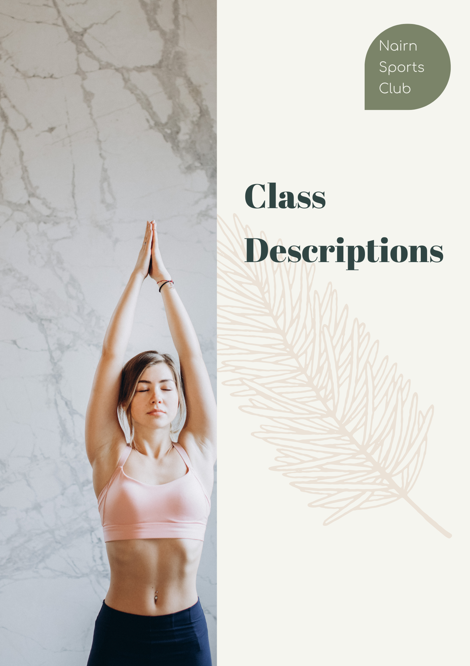
Class Descriptions
Fit4Life
This is a class tailored to the older adult. It is a low impact workout and is suitable for all fitness levels.

ZUMBA
Zumba is a dance-based work-out to upbeat Latin and international music that just makes you want to move to the rhythm of the beat!

ENERGY BOOST
Low impact workout suitable for all fitness levels. Works on improving posture, building strength and gaining flexibility leaving you feeling more energised. Total body workout, working on arms, legs, bum and stomach.

Yoga
Yoga encourages you to focus on your body, mind and breath. Regular practice reduces stress and increases your strength, flexibility, coordination and balance. In this class, we will be working on a mat (standing, seated, lying and on all fours) with optional extra props such as a yoga strap or blocks. Every session includes a short period of guided relaxation, and simple yet effective breathing exercises will be taught regularly. This class is suitable for all levels of experience, including beginners.

SPIN CLASS
Spinning takes part on a bike focusing on endurance, strength, intervals, high intensity and recovery. Set in a dim lit room you will get lost in the music and forget how hard you are working!!

Full Body BarBell
This time related interval circuit class, using Bar bells exercises working the whole muscular range and extending Cardio Vascular fitness levels throughout.

TABATA, ABS & STRETCHING
High or low impact timing related online exercise class. 5 individual exercises targeting different muscle groups each of which you will complete 8 times for 20 seconds best effort interspersed with 10 second rest periods.
The 20 Minute Core section will be followed by 10 Minutes of deep stretching with the focus changing every session.

Bar & Bike
Bar &Bike - suitable for all from Novice to Experienced user. Focus on correct Bar Bells & Bike techniques throughout. Perfect balance of spinning & weighted bar exercises.

BEGINNERS PILATES
Bring healing to your body and peace to your mind. Aimed at strengthening muscles while improving posture alignment and flexibility.

BARRE
Barre class is low impact and suitable for all fitness levels, toning body weight workout to fine tune your muscles, squats, lunges and sit ups.

Female Only Gym Sessions
Female Only Gym Sessions. Learn the basics with circuit sessions. Full Body Workout, 1-1 support, burn calories and be shown the correct techniques using Cardio, Fixed and Free Weights. (Limited frequency).

Stable & Strong
This is a slower paced class for the older adult who wishes to improve balance strengthening muscles and maintaining bone strength.

Functional Fitness
We don’t want to stick a label on this class, we just want to encourage everyone to feel comfortable exercising.
As we get older it is vital to maintain and improve your bone density as well as improving your muscle strength and balance, In this low impact, new circuit style class, you will be using cardio and strength equipment. All exercises can be adapted to suit your ability with lots of encouragement to push yourself in a safe and relaxed environment
NSCROX
This is a multifunctional circuit class, based on the fundamental principles of the fitness racing phenomena currently sweeping the health & fitness world.
Our circuit class pays homage to the competition level, using the same equipment range, associated techniques and in a timed format.
This class is aimed at a higher level, the exercises are safe and fairly simple to perform, but you will be challenged and worked hard.

Body Blast

If you’re looking for a great head-to-toe workout then this is the class for you.
The class involves completing reps with a choice of weights, different timings and various tempos. This class is great for all ability levels and will allow you to practice basic exercises while toning your whole body.

Mind Fit
A Mind Fit class is aimed at introducing you to ways of training your brain for overall wellbeing. It will help you find ways to train the mind to be positive, kind, and helpful by stepping out of constant busyness, over thinking, distancing yourself from unhelpful thoughts, ultimately to develop a sense of peace and calm in the mind.
Each class will introduce you to a guided mindfulness practice, provide the underlying scientific theory such as neuroscience and include a discussion on the experience of the practice. The Mindfulness practice will help you build and strengthen your innate ability to pay attention on purpose, be present, calm and joyful. By developing our mindfulness muscle, we build a deeper understanding of the mind-body connection, enhance our emotional resilience and the inner strength to confidently face the many challenges we encounter in an ever-changing world.
Class will take place in the hall, which will be heated and we recommend you take a blanket if you prefer to lie down during the practice.

Box Fit
Box fit is a high intensity cardio workout based on boxing techniques using gloves and pad work. Suitable for all levels to improve your agility, strength and overall fitness.

